ISOM 2000 FOR MTBO MAPPING IN AUSTRALIA

REVIEW AND RECOMMENDATIONS FOR MTBO WOC 2004

Version 2 - January 2003

SUMMARY OF RECOMMENDATIONS

The following changes are recommended to the ISOM 2000 MTBO specifications:

Changes and Additions to Current Specifications:
- Water and Marsh symbols - delete black bank line from symbols 301 Lake, 304 Uncrossable river and 309 Uncrossable marsh
- Man-made Features - add Foot-O symbols 510 Visible path junction, 511 Indistinct junction, 513 Crossing point with bridge, 514 Crossing point without bridge
- Man-made Features - change gap lengths for 813 Track: slow riding and 814 Path: slow riding; and reduce line widths for all Track and Path symbols (these changes are incorporated in the revised track symbols below)
Changes to Track Classification System and Symbols
- Change primary method of classification of tracks to the significance of the track, rather than the width of the track (using similar criteria to Foot-O)
- Add new symbols for indistinct tracks or paths corresponding to Foot-O symbol 508 Less distinct path
- Change the definition of path to limit the use of this symbol to narrow path (Foot-O definition) or "single track" (MTB definition) due to the technical difficulty of riding this type of track irrespective of riding surface
- Provide two line widths for roads and vehicle tracks to allow for wide range of tracks represented by Foot-O symbols 504, 505 and 506, which are currently represented by only one line width in the MTBO specifications
The recommended system of classification and symbols (legend enlarged to twice map scale) are:
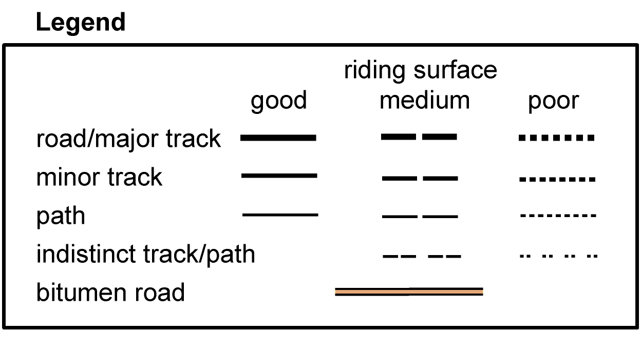

1. PREAMBLE

The ISOM 2000 specifications for MTBO maps have been used for most new specially prepared MTBO maps in Australia in 2001 and 2002, including the 2002 Australian Short Distance and Long Distance (Classic) Championships. The most recent maps have used the revised ISOM MTBO specifications (2002 revision, pre MTBO WOC 2002).

A number of problems have arisen in using the ISOM specifications for Australian terrain (track and path mapping in particular). These problems are detailed below, along with recommendations for changes to the ISOM 2000 specifications for MTBO maps for implementation prior to MTBO WOC 2004.

It is essential that the issues raised in this paper are resolved prior to MTBO WOC 2004, possibly in conjunction with the IOF Controller for the event, to ensure that overseas competitors in particular are not disadvantaged by the representation and interpretation of tracks on Australian MTBO maps.

2. BACKGROUND

Australia has confirmed its status as one of the leading MTBO nations through its performances in MTBO WOC 2002. The excellent performance of the Australian competitors has been built on high standard competition within Australia on challenging terrain with (mostly) specially prepared MTBO maps.

The high standard of MTBO mapping in Australia was established by Rob Plowright (one of the leading mappers in Australia - who has also prepared maps for international Foot-O events elsewhere in Asia including the 2001 World Games). Rob's earliest MTBO maps were for the 1997 and 1998 Victorian MTBO Championships and the 1998 Australian MTBO Championships. These maps are still regarded as outstanding MTBO maps. These maps of course pre-dated ISOM 2000 and any other international MTBO map specifications. Rob developed a system of track classification similar in concept to that subsequently published in ISOM 2000, but which used more grades of tracks. Over the period 1997-2000, Rob refined the symbols (line width and dash/gap length) based on feedback from the various events. A sample of the system of track classification used by Rob Plowright in his later maps is shown below (legend enlarged to twice map scale).

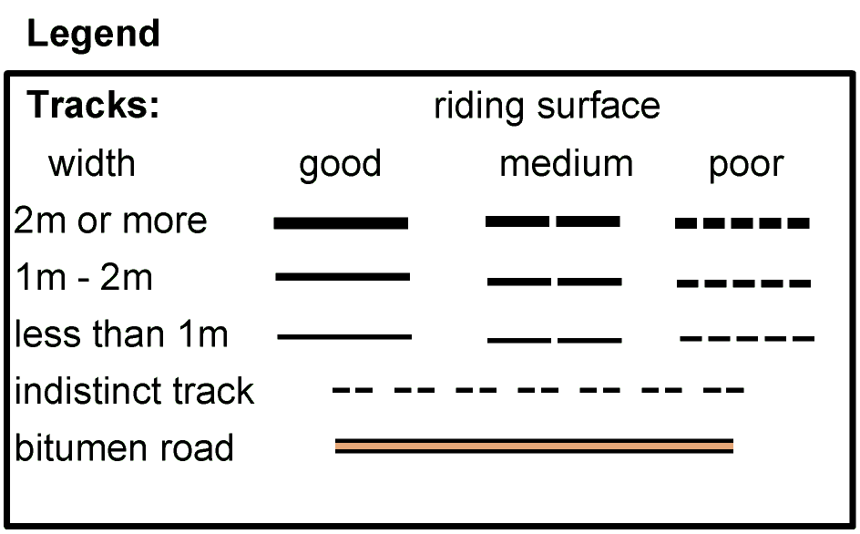

This system of track classification was adopted as a de-facto Victorian MTBO mapping standard until ISOM 2000 was published. However, many MTBO events were conducted on Foot-O maps in the period 1998-2000, and some specially prepared MTBO maps still used Foot-O track classifications and symbols.

In 2001 and 2002 several mappers used the ISOM 2000 MTBO specifications for some new and remapped MTBO maps. These maps have received a mixed reception from competitors, who had been used to having a wider range of track classifications. However, the consensus was that the ISOM 2000 MTBO specifications should be used for all new MTBO maps, particularly in the lead-up to MTBO WOC in 2002 in France.

The 2002 Australian Short Distance and Long Distance (Classic) Championships were held in November 2002 on specially prepared MTBO maps using the ISOM 2000 MTBO specifications (2002 Revision). The two areas had been mapped previously for Foot-O, though the MTBO maps covered larger areas than the Foot-O maps. Both areas were native (eucalypt) forest, and are generally similar to the type of terrain likely to be used for MTBO WOC in 2004.

The Long Distance Championship map in particular provided a very poor representation of the tracks using the ISOM MTBO specifications compared to the Foot-O map. The inability of the mappers and cartographer to adequately represent the range of tracks using the ISOM MTBO classification system was the main issue. There were two major problems:

(1) The treatment of what are mapped as indistinct tracks on the Foot-O map.
Most of these tracks are rarely used vehicle tracks which are wider than 1.5 metres. The mappers were faced with the decision to:
- leave the tracks off the map, or
- use symbols 813 (Track: slow riding) or 815 (Track: difficult to ride), both of which gave the competitor a picture of a track that was much more obvious and easy to follow than was the case, due to the 0.6 mm line width.
The mappers generally chose to map the tracks with symbols 813 or 815, which resulted in navigational problems for competitors who were expecting to find significant and distinct tracks.

This problem is not unique to this particular map or area. It is a general problem in Australian forests since indistinct vehicle tracks from logging or firewood collection activities are very common. Although these tracks are indistinct, it is essential that they be mapped with an appropriate symbol to enable proper navigation.

(2) The range of tracks that had to be mapped with symbols 811 (Track: easy riding), 813 (Track: slow riding) and 815 (Track: difficult to ride).
The majority of the tracks on the map are wider than 1.5 m. They include well surfaced forest roads (gravel surface), major vehicle tracks, minor vehicle tracks and indistinct vehicle tracks (see above). This meant that one track symbol width had to be used to represent a wide range of tracks which looked very different on the ground. This made navigation difficult, since competitors did not know whether to expect a road, major vehicle track or minor vehicle track when making navigational decisions.

Again, this problem is not unique to this particular map or area. It is a general problem in Australian forests since there is a wide range of forest roads and vehicle tracks in most native (eucalypt) forest areas.

[It was intended that photographs of specific examples of the types of tracks described here would be included in this document, along with the relevant sections of the MTBO and Foot-O maps. The original timetable for discussion and consideration of this document was set without knowledge of the IOF Committee Meetings in January 2003.]

3. RECOMMENDED CHANGES TO ISOM 2000 MTBO SPECIFICATIONS

The following recommended changes include several which are based on experience over a number of years with ISOM and pre-ISOM symbols, as well as those related to the problems experienced in Australia in applying the ISOM track classification system and symbols

3.1 Changes and Additions to Current Specifications

3.1.1 Water and Marsh

The following water and marsh symbols have black bank lines indicating that the feature cannot be crossed:
301 Lake, 304 Uncrossable river, 309 Uncrossable marsh

The presence of this bank line is irrelevant for MTBO. The black bank line should be omitted.

The presence of the black bank line could cause confusion where there are tracks or paths near the lake, river or marsh.

3.1.2 Man-made Features

The following ISOM Foot-O symbols have been omitted from the ISOM MTBO recommended symbols:
510 Visible path junction, 511 Indistinct junction
513 Crossing point with bridge, 514 Crossing point without bridge

The omission of 510, 511, 513 and 514 would seem to be an oversight. The information provided by these symbols is arguably more important for MTBO, which is conducted entirely on tracks, than for Foot-O. The information is even more important for MTBO than for Foot-O when the speed of a rider compared to a runner is taken into account. It is critically important for an MTBO competitor to know whether a track junction is distinct or indistinct, or whether a creek has a bridge or water crossing, when making route choice decisions or navigating along a chosen route.

These four symbols should be added to the list of Man-made features in Section 6.6.1 Use of foot-O symbols.

3.1.3 Gap Lengths - Symbols 813 and 814

The 2002 revision of the ISOM MTBO specifications increased the gap lengths from 0.5 mm to 0.8 mm and 0.7 mm respectively for symbols 813 (Track: slow riding) and 814 (Path: slow riding). This was presumably done to improve legibility of the dashed tracks compared to the continuous lines of symbols 811 and 812. However, this increased gap length has meant that (sharp) track bends near the gaps in the line may result in the track not appearing to be continuous. While an OCAD "Corner Point" or "Dash Point" can be used to force a dash rather an a gap at a particular point, this may result in uneven dash lengths.

The gap length should be reduced back to 0.5 mm for both symbols (or to 0.6 mm for 813 and 0.5 mm for 814). These changes are incorporated in the revised track symbols below.

3.1.4 Line Widths

The 2002 revision of the ISOM MTBO specifications also increased the line width from 0.35 mm to 0.4 mm for symbols 812 (Path: easy riding), 814 (Path: slow riding) and 816 (Path: difficult to ride). This was presumably done to improve legibility of the path symbols.

Symbols 811 (Track: easy riding), 813 (Track: slow riding) and 815 (Track: difficult to ride) have a line width of 0.6 mm.

These 0.6 mm line widths, which represent 15 m on the ground at 1:25,000, have been too wide to use in areas of complex, closely spaced tracks, and some mappers in Australia and New Zealand have reduced the line widths for these symbols.

The line width for 811, 813 and 815 should be reduced to 0.5 mm, and the line width for 812, 814 and 816 reduced correspondingly to 0.3 mm or 0.25 mm to maintain an adequate relativity. These changes are incorporated in the revised track symbols below.

3.2 Changes to the Track Classification System and Symbols

The road and track classifications for Foot-O are based primarily on how significant the track appears on the ground. There are five (black) symbols to cover the range of forest roads, tracks and paths: 504 (Road), 505 (Vehicle track), 506 (Footpath), 507 (Small path) and 508 (Less distinct small path). The line widths reflect how significant the track appears to the (Foot) Orienteer.

The current Ski-O and MTBO track classifications are based principally on the width of the track.

For Ski-O this is sensible, since the underlying road or track is snow covered, meaning that differences in appearance are irrelevant. In addition, track width is important in determining whether a skier can skate (wider track) or must diagonal stride or double pole (narrow track).

The current MTBO track classifications based on width were presumably based on analogy with the Ski-O classification (which pre-date the MTBO specifications), with the logic that the ability to pass other riders is a major factor.

For MTBO, how significant the track appears on the ground would seem to be a better primary basis for track classification than width alone. This is based on the logic that the MTB Orienteer and the Foot Orienteer observe the same information in the field, and have to make the same navigational decisions based in the visual significance of the track. The current ISOM MTBO specifications have reduced the ability to represent visual significance by only having two line widths to represent what is covered by five symbols (and line widths) in the Foot-O specifications. There is a balance between having a small number of symbols with significantly different line widths to enable easy map reading at riding speed, and having enough symbols to properly represent the range of tracks which the rider will encounter.

Imagine the following:
In 2003, the IOF introduces a new discipline - Track-O. Track-O is a form of Foot-O where the competitors must only run on the mapped tracks. The IOF Map Commission determines that the map specifications for Track-O will not be the same as for Foot-O, but will have new symbols to represent how wide the tracks are, and how easy or difficult they are to run on. These new symbols will only have two line widths but have continuous or dashed lines to indicate the running difficulty.
This is clearly an absurd proposition, but is essentially what the ISOM MTBO map specifications currently provide !

There is also an implied relationship (in the ISOM symbol descriptions) between the riding surface and the extent to which a track is used (and hence its visual significance). In Australia, and presumably in other parts of the world, there are many cases where a track would be regularly used by vehicles (and therefore visually significant), but have a poor or very poor surface for riding due to erosion, loose stones, large rocks or sand. For example it is very common in Australia for vehicle tracks used by four-wheel drive vehicles to be very significant and distinct but have a poor or very poor riding surface due to ruts or rocks. It is also reasonably common for minor vehicle tracks to have a moderate riding surface since they are infrequently used by vehicles and are therefore not rutted.

There is therefore a need to be able to independently represent the significance of a track and the ridability to a greater extent than is currently provided for in the ISOM 2000 MTBO track classifications.

MTBO essentially involves two components: route choice and navigation.

The map information required for route choice is distance, height difference, track ridability (riding speed) and complexity of decisions to be made on the route (likely navigational difficulty). The current ISOM MTBO map specifications and track classifications provide this information relatively well.

The map information required for navigation is how the map represents what the rider will see when the selected route is executed. It is in this aspect that the current MTBO track classifications are inadequate for Australian terrain, since the rider is not able to properly anticipate the significance (and hence the appearance) of a track in order to make the correct navigational decisions.

The recommendations below are based in the logic that the MTBO track classifications must be more closely related to the Foot-O classifications, based primarily on visual significance of the track. A sample of the symbols for the recommended classifications is provided at the end of this section.

3.2.1 Indistinct Tracks or Paths

It is recommended that a similar symbol to Foot-O symbol 508 (Less distinct small path) be introduced. This symbol would have two dash lengths to indicate slow or difficult riding.

It is essential that such a symbol be included so that tracks which are indistinct or partly overgrown, but which are visible to a rider, can be adequately represented. The current situation, where mappers must decide whether to leave such tracks off the map entirely, or to map them with symbols 813 (Track: slow riding) or 815 (Track: difficult to ride) with a 0.6 mm line width is clearly unsatisfactory. If the mapper decides to leave the track off the map, then the competitor is disadvantaged because he/she then has to make a decision as to whether a track is on the map or not, and may make an inadvertent navigational error.

3.2.2 Paths (Single Track)

Paths (Orienteering terminology) or Single Track (MTB terminology) require a separate symbol from wider tracks. Paths or Single Track are generally less than 1 m wide and are small footpaths, MTB tracks or motor cycle tracks. Irrespective of the riding surface, single track requires a higher level of technical riding skill, since the track generally has many more direction changes, has more minor height changes than vehicle tracks, and being very narrow has more likelihood of handlebars striking trees. These direction changes and height changes cannot be shown at MTBO map scale. It is also difficult to pass or overtake another rider on single track.

It is important that sufficient information is provided by the track classifications so that riders can make a route choice decision taking into account their technical riding skill as well as their fitness and riding speed.

It is recommended that a symbol be dedicated to Paths/Single Track, with the current three grades of ridability also shown. This would represent what is generally shown on Foot-O maps by symbol 507 and on current MTBO maps by symbols 812, 814 and 816, but with the definition of path changed to limit the use of this symbol to narrow paths and single track.

3.2.3 Roads and Vehicle Tracks

Forest roads and wider tracks on Foot-O maps are represented by symbols 504, 505 and 506. As discussed above, these cover a wide range of roads and track on the ground.

It is recommended that two line widths be used to cover this range of roads and tracks, replacing the single line width in the current ISOM MTBO specifications. These two line width symbols would be described as forest road/major (vehicle) track and minor (vehicle) track.

A sample of the recommended system of track classification is shown below (legend enlarged to twice map scale).

The dimensions and descriptions of the recommended symbols is as follows:

811 Road: easy riding (Line width: 0.5 mm)
A well maintained forest road or major track with stabilised surface and no obstacles. Width less than 3 m.

812 Vehicle track: easy riding (Line width: 0.35 mm)
A minor vehicle track or constructed bicycle path with smooth surface and no obstacles. Width less than 3 m.

813 Path: easy riding (Line width: 0.25 mm)
A well maintained path or narrow bicycle path with smooth surface and no obstacles. Width less than 1 m.

814 Road: slow riding (Line width: 0.5 mm, dash length 3.0 mm, gap length 0.5 mm)
A forest road or major track with ruts, loose stones, mud or sand. Pedalling is more difficult and riding is slowed. Width less than 3 m.

815 Vehicle track: slow riding (Line width: 0.35 mm, dash length 3.0 mm, gap length 0.5 mm)
A minor vehicle track or unsurfaced wide bicycle path with ruts, loose stones, mud or sand. Pedalling is more difficult and riding is slowed. Width less than 3 m.

816 Path: slow riding (Line width: 0.25 mm, dash length 3.0 mm, gap length 0.5 mm)
A path or narrow bicycle path with ruts, loose stones, mud or sand. Pedalling is more difficult and riding is slowed. Width less than 1 m.

817 Road: difficult to ride (Line width: 0.5 mm, dash length 0.6 mm, gap length 0.4 mm)
A forest road or major track with deep ruts, erosion, loose stones, large rocks, mud or sand. Very slow or impossible riding. Width less than 3 m.

818 Vehicle track: difficult to ride (Line width: 0.35 mm, dash length 0.5 mm, gap length 0.4 mm)
A minor vehicle track or unsurfaced wide bicycle path with deep ruts, erosion, loose stones, large rocks, mud or sand. Very slow or impossible riding. Width less than 3 m.

819 Path: difficult to ride (Line width: 0.25 mm, dash length 0.4 mm, gap length 0.4 mm)
A path or narrow bicycle path with deep ruts, erosion, loose stones, large rocks, mud or sand. Very slow or impossible riding. Width less than 1 m.

820 Less distinct track or path: slow riding (Line width: 0.25 mm, dash length 2.0 mm, minor gap length 0.3 mm, major gap length 1.0 mm)
A rarely used vehicle track or path with leaves, branches, ruts, loose stones, mud or sand. Pedalling is more difficult and riding is slowed.

821 Less distinct track or path: difficult to ride (Line width: 0.25 mm, dash length 0.4 mm, minor gap length 0.3 mm, major gap length 1.0 mm)
A rarely used vehicle track or path with leaves, branches, deep ruts, erosion, loose stones, large rocks, mud or sand. Very slow or impossible riding.

Prepared by: Peter Jackson for Victorian Orienteering Association
peter.jackson@cleanpower.com.au

