Color changes in MTBO maps

Black = road, track and path network
For the sake of legibility and reading error reduction is black used
exclusively for the roads, tracks and paths.

The other originally black symbols

Narrow rides without track = green
The rideable rides are drawn as roads, tracks or paths. The not rideable but clearly visible rides are drawn with green (vegetation feature).
Ride is prohibited like in the forest.

Other man-made features (buildings, rocks,...)= dark purple
The symbols are legible in whatever context, also in the neighbourhood of tracks and paths and do not deteriorate their perception.

Settlements = gray
Settlements (gardens, yards) with no entry to competitors except of roads, tracks and paths. Improvement of track legibility compared to original yellow/green raster.

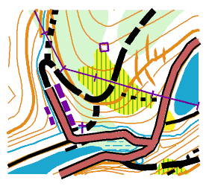
With original black colour of buildings, it is often not possible to distinguish between e.g. line of buildings and a slow ride road. The exclusive use of black for roads, tracks and paths improves the legibility of map

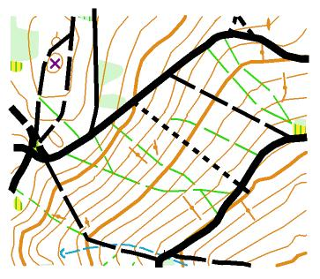
The ride on rides without track is forbidden - similarly as it is through the forest. The rides with track/path are drawn as tracks/paths. The no ride rides should be drawn preferably in the areas with dense network of rides, some of them rideable and some not.

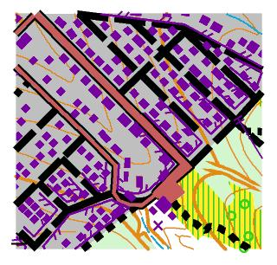
Compared to the original yellow/green raster the gray background improves the legibility of the upper symbols.
The difference to the neighbouring green thicket is bigger.

