3/4 November 2007 – Cessnock
Mountain Bike Orienteering
Australian Championships
Welcome
Big Foot Orienteers Inc. welcomes all riders to the 2007 Australian Championships. This event is open to all riders of all standards, not just those wishing to compete for an Australian title.
The championships will be contested in specified age classes. Non-championship (or open) classes are also offered for those who want to ride an easier course. This event is an excellent opportunity for all riders to experience the best maps and courses that MBO has to offer!
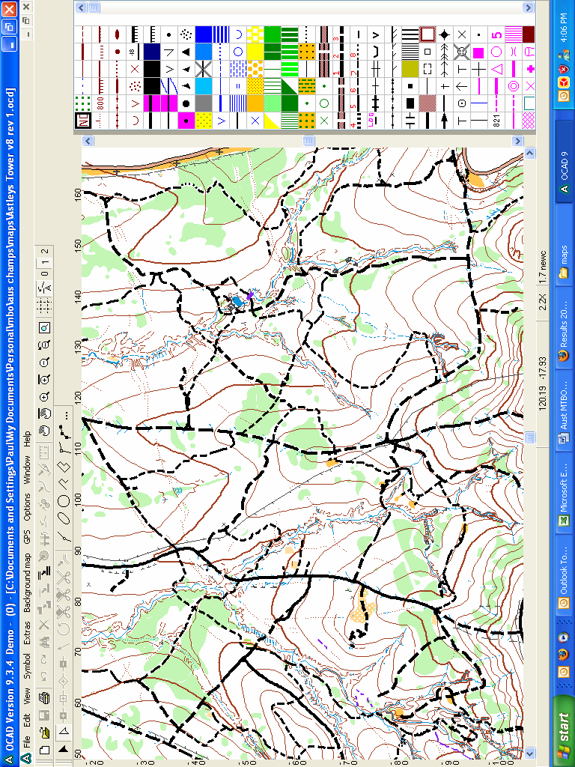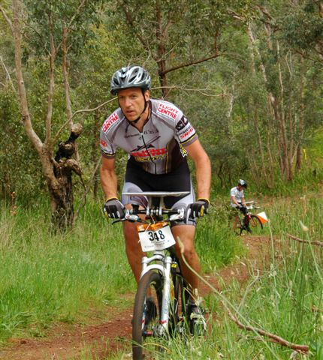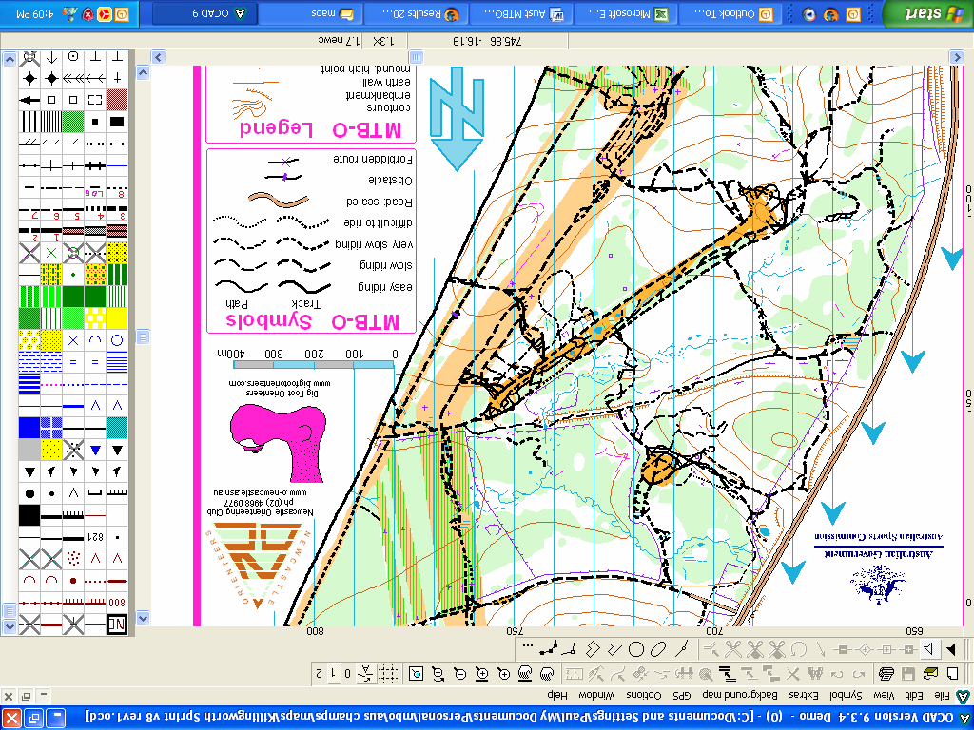
Races
The Championships will be contested over three distances; sprint, middle and long. The timing for races over the weekend will be:
Saturday 3 November Australian Middle Distance Championships (morning)
Saturday 3 November Australian Sprint Distance Championships (afternoon)
Sunday 4 November Australian Long Distance Championships (morning)
The elite men and women’s middle and long distance courses are World Ranking Events.
Venue and terrain
The three areas are near Cessnock. All three areas are outstanding MBO terrain, mostly flat to undulating and have a dense network of single tracks and 4wd tracks. The three maps have been specially prepared by Andrew Slattery (WOC mapper) and Denis Lyons.
Directions
Full directions to each race will be provided later.
Classes
Course 1: Men Elite
Course 2: M-20, M40-, Women Elite, M Open B
Course 3: M-16, M50-, W-20, W40-, W Open B, M Open C
Course 4: M 60-, W-16, W 50-, M Open D, W Open C
Course 5: M 70+, M-14, W60+, W-14, W Open D
Any class with fewer than 5 entries may be combined with the nearest class.
Courses
Details of the courses are set out below. Distances and climb are measured by the optimum route.
Sprint distance
The sprint race terrain is generally flat with a few small hills. Track speed varies greatly, due to occasional rocky sections and ruts, but is generally fast. The area is dominated mostly be 4wd tracks, but has some single track created by motorbikes. There is a moderately dense network of tracks and paths with a number of areas of very complex networks. The broad, flat areas between the hills get flooded after rain and can have many puddles. The biggest possible climb on the map is 40 metres.
Sprint courses will be short, flat, fast and have many check points. The map scale will be 1:7,500.
Course | Distance (km) | Climb (m) | Check points | Expected winning time (min)
1 | 7 | 100 | 16 | 20
2 | 5 | 60 | 12 | 20
3 | 5 | 50 | 13 | 20
4 | 4 | 40 | 11 | 20
5 | 4 | 30 | 10 | 20
Middle distance
The middle distance race terrain is generally undulating. Two steep ridges are separated by a number of broad, gentle spurs and large flatter areas. Track speed is generally fast, but varies greatly. In addition to the many 4wd tracks there is an extensive network of fast, flowing single track made for mountain bike racing. Some parts of the area have very thick, heavy mud after rain and tracks in the flatter parts of the map can have many puddles.
The middle distance courses will generally be flat to undulating with a mixture of long and short legs between check points. The map scale will be 1:10,000.
Course | Distance (km) | Climb (m) | Check points | Expected winning time (min)
1 | 19 | 300 | 18 | 50
2 | 14 | 180 | 15 | 45
3 | 12 | 150 | 13 | 45
4 | 10 | 120 | 13 | 45
5 | 8 | 100 | 10 | 45
Long distance
The long distance race terrain consists of a steep ridge with a large gently sloping area. The whole area has a very dense network of 4wd tracks and single tracks made by motor bikes. Track speed varies greatly. Overall the area is fast but has many small sections of rock, sand and can have mud after rain.
The long distance courses will generally be flat to undulating with the longer courses going into the steeper sections of the map. The courses will have a mixture of long and short legs between check points. The map scale will be 1:15,000.
Course | Distance (km) | Climb (m) | Check points | Expected winning time (min)
1 | 35 | 500 | 30 | 110
2 | 25 | 300 | 23 | 90
3 | 20 | 250 | 21 | 80
4 | 15 | 200 | 18 | 80
5 | 12 | 150 | 15 | 70
Race programme
Saturday Middle distance - Starts from 10:00am
Sprint distance - Starts from 3:00pm
Sunday Long distance – Starts from 10:00am
Punching system
The Sportident electric punching system will be used at check points for all races. Units will be available for hire.
Accommodation
Accommodation anywhere in the Cessnock-Maitland-Newcastle-Morisset area has good access to the race venues. For anyone wishing to stay in Sydney the race venues are up to 90 minutes drive from the start of the F3 in Hornsby.
Training possibilities
Training maps will be available for interstate and overseas competitors. We recommend the following training opportunities:
27/28 October – NSW Championships near Lithgow. A great area on a new map with a sprint race Saturday afternoon and long distance race Sunday.
29 October – 2 November (mid week). Maps are available for the following areas near Lithgow:
Sunny Corner (1:20,000, 2002)
Duckmaloi (1:20,000, 2003)
Black Springs (1:20,000, 2004)
Around Sydney:
Yellomundee (1,7,500, 2007)
Glenbrook (1:7,500, 2006)
Paul’s backyard (1:25,000, 2006)
Near Newcastle:
The Lot (1:15,000, 2007)
Wallaroo (1:20,000, rev 2007)
Anyone wanting to train on these maps should contact the organiser.
Entries
See http://www.bigfootorienteers.com for online entry from beginning of October 2007. Entries close Friday 26th October 2007. To Australian MTBO Champs, c/- 58 Dorset Drive, St Ives NSW 2075. Cheques payable to Big Foot Orienteers.
Entry Fees: Seniors (15 and over) $35 per day ($100 for all 3 events), Juniors (under 15) $20 per day ($55 for all 3 events), Family (1 senior +2 juniors) $80 per day ($220 for all 3 events). Seniors who are not a member of an orienteering club must pay $5 per day extra, even if in a family entry.
Start lists
Start lists will be provided later.
Organiser: Paul Darvodelsky. Phone 0407 152 168 Email pd@psd.net.au for Big Foot Orienteers Inc. Planner: Mark Shingler. Event adviser: Terry Bluett. Webmeister: Anthony Darr.

