Taranaki Secondary Schools Rogaine.

On Wednesday 30th March, 457 secondary school students turned out for the TSSSA rogaine held in Lake Mangamahoe. This was a 3 hour event run from 6pm till 9pm giving students around 90 minutes of night navigation. The area is primarily steep pine forest mixed with native and includes a mountain bike park.

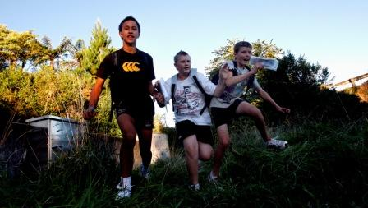
Obviously the size of the turnout was something of a surprise to the organisers and with only 45 minutes to manage registration changes, issue maps, fit Navlight tags and brief the students, the pressure was on. We managed it and with 2 minutes to spare were ready to go.

For many this was a serious competition and as expected, New Plymouth Boys High, and Opunake High Schools dominated winning 3 grades each. Also winning grades were Spotswood College and New Plymouth Girls High School. Full results can be found at http://bubbles.school.nz/tssrogaine2011/Results.htm .

The growing success of this event has got the organisers baffled, but it is now the biggest Secondary School Event on the Taranaki calendar and the largest rogaine in NZ with the exception of last years World Champs.

Search and Rescue planning in what was a difficult area proved to be challenging and we relied heavily on texting to guide a few lost students home. Witness this conversation:

Student: We lost on the lower lake circuit do we go up or around
Me: Up and south
S: We at redwood where nw
Me: Go up
S: We on gravel track
Me: Keep going
S: Up?
Me: Yes
S: Thank You
S: We still lost
Me: What was your last control?
S: We back thanks a lot

We look forward to next year’s event and are hoping we can break the 600 mark.

Nick Collins

